**Name Muhammad Waseem Riaz**

**Reg Num: FA22-BSE-055**

**Task:2**

**CAR INSPECTION AND NANAGEMENT SYSTEM**

Car inspections involve a comprehensive assessment of a vehicle's condition, focusing on safety, efficiency, and regulatory compliance. Key components typically inspected include:

* **Brakes**: Evaluation of brake pads, fluid levels, and overall responsiveness.
* **Lights**: Functionality of headlights, brake lights, and turn signals for visibility.
* **Tires**: Checking tread depth and overall tire condition for adequate traction.
* **Emissions System**: Ensuring compliance with environmental regulations to minimize pollution

Preparation for Inspections

Effective preparation is crucial for a successful inspection. Here are essential steps:

* **Documentation**: Gather necessary documents such as vehicle registration, proof of insurance, and previous inspection reports. This demonstrates a commitment to vehicle maintenance
* **Personal Maintenance**: Regularly check fluid levels, tire pressure, and other critical components to identify potential issues earlyInspection Management Strategies

Establishing a Routine

Implement a regular inspection schedule based on manufacturer recommendations and local regulations. This proactive approach helps avoid lapses in inspections and ensures vehicles remain roadworthy

.

Utilizing Technology

Leverage technology to streamline the inspection process:

* **Digital Checklists**: Use mobile applications that provide reminders for upcoming inspections and allow for on-the-go assessments

.

* **Data Analytics**: Employ predictive analytics to anticipate potential issues based on historical data, enhancing fleet reliabilityDocumentation and Record-Keeping

Maintain organized records of inspections, repairs, and maintenance activities. Digital documentation simplifies access to essential information and aids in tracking vehicle performance over time

.

Best Practices During Inspections

Comprehensive Checklists

Utilize detailed checklists during inspections to ensure all critical components are evaluated. This includes both pre-trip checks (before operating the vehicle) and post-trip assessments (after use) to catch any issues that may have arisen during operation

.

Communication with Technicians

Regularly engage with inspection service providers to understand recurring issues or necessary repairs. This communication helps prioritize maintenance tasks effectively

.

Customer Feedback Integration

For rental fleets or services, integrating customer feedback into the inspection process can enhance service quality. Addressing concerns promptly not only improves safety but also builds trust with customers

.

**composite structure diagram**

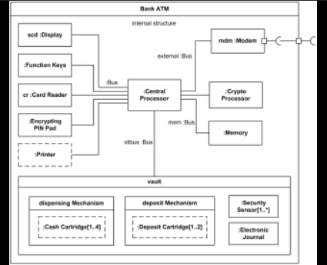

**Class Diagram**

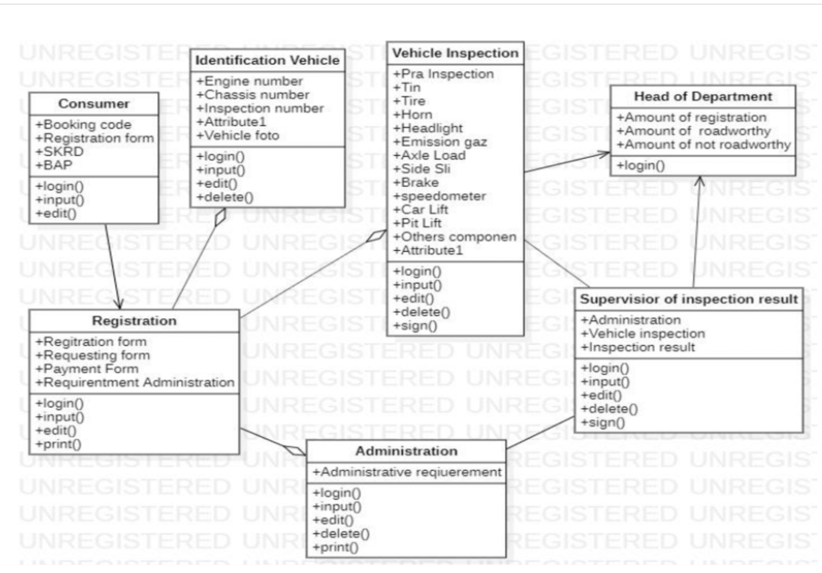

**Sequence Diagram**

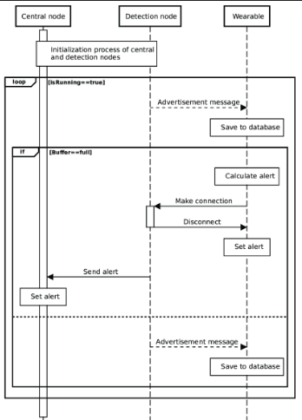

**Use Cause Diagram:**